**Date:22/2/24 EXPERIMENT 7**

**Name:Rithika shree**

**21R231**

**Camera Calibration and Pose Estimation using Monocular Camera**

**Aim:**

To calibrate a Monocular Camera and estimate the pose using OpenCV.

# **Software/ Packages Used:**

1. Pycharm IDE
2. Libraries used:
   * NumPy
   * opencv-python
   * matplotlib
   * scipy

# **Programs:**

# **Camera Calibration**

**FOR JPG IMAGE**

**INPUT**

import numpy as np  
import cv2 as cv  
import glob  
################ FIND CHESSBOARD CORNERS - OBJECT POINTS AND IMAGE POINTS #############################  
  
#chessboardSize = (24,17)  
#frameSize = (1440,1080)  
  
#chessboardSize = (10,17)  
frameSize = (640,480)  
  
# termination criteria  
#criteria = (cv.TERM_CRITERIA_EPS + cv.TERM_CRITERIA_MAX_ITER, 30, 0.001)  
  
  
# prepare object points, like (0,0,0), (1,0,0), (2,0,0) ....,(6,5,0)  
#objp = np.zeros((chessboardSize[0] * chessboardSize[1], 3), np.float32)  
#objp[:,:2] = np.mgrid[0:chessboardSize[0],0:chessboardSize[1]].T.reshape(-1,2)  
  
#size_of_chessboard_squares_mm = 20  
#objp = objp * size_of_chessboard_squares_mm  
  
# termination criteria  
criteria = (cv.TERM_CRITERIA_EPS + cv.TERM_CRITERIA_MAX_ITER, 30, 0.001)  
# prepare object points, like (0,0,0), (1,0,0), (2,0,0) ....,(6,5,0)  
objp = np.zeros((9*6,3), np.float32)  
objp[:,:2] = np.mgrid[0:9,0:6].T.reshape(-1,2)  
# Arrays to store object points and image points from all the images.  
objpoints = [] # 3d point in real world space  
imgpoints = [] # 2d points in image plane.  
  
images = glob.glob(r'C:\Users\rithi\PycharmProjects\pythonProject6\calib\ima*.jpg')  
  
for image in images:  
  
 img = cv.imread(image)  
 gray = cv.cvtColor(img, cv.COLOR_BGR2GRAY)  
  
 # Find the chess board corners  
 #ret, corners = cv.findChessboardCorners(gray, chessboardSize, None)  
 ret, corners = cv.findChessboardCorners(gray, (9,6), None)  
 # If found, add object points, image points (after refining them)  
 if ret == True:  
  
 objpoints.append(objp)  
 corners2 = cv.cornerSubPix(gray, corners, (11,11), (-1,-1), criteria)  
 imgpoints.append(corners)  
  
 # Draw and display the corners  
 #v.drawChessboardCorners(img, chessboardSize, corners2, ret)  
 cv.drawChessboardCorners(img, (9,6), corners2, ret)  
 cv.imshow('img', img)  
 cv.waitKey(1000)  
  
  
cv.destroyAllWindows()  
  
  
  
  
############## CALIBRATION #######################################################  
  
ret, mtx, dist, rvecs, tvecs = cv.calibrateCamera(objpoints, imgpoints, frameSize, None, None)  
  
np.savez('B.npz', mtx=mtx, dist=dist, rvecs=rvecs, tvecs=tvecs)  
print('Calibration Completed')  
############## UNDISTORTION #####################################################  
  
img= cv.imread(r'C:\Users\rithi\PycharmProjects\pythonProject6\Calib\cali7.jpg')  
  
cv.imshow('img', img)  
h, w = img.shape[:2]  
newCameraMatrix, roi = cv.getOptimalNewCameraMatrix(mtx, dist, (w,h), 1, (w,h))  
  
# Undistort  
dst = cv.undistort(img, mtx, dist, None, newCameraMatrix)  
  
# crop the image  
x, y, w, h = roi  
dst = dst[y:y+h, x:x+w]  
cv.imwrite('caliResult1.jpg', dst)  
  
  
  
# Undistort with Remapping  
mapx, mapy = cv.initUndistortRectifyMap(mtx, dist, None, newCameraMatrix, (w,h), 5)  
dst = cv.remap(img, mapx, mapy, cv.INTER_LINEAR)  
  
# crop the image  
x, y, w, h = roi  
dst = dst[y:y+h, x:x+w]  
cv.imwrite('caliResult2.jpg', dst)  
  
  
  
  
# Reprojection Error  
mean_error = 0  
  
for i in range(len(objpoints)):  
 imgpoints2, _ = cv.projectPoints(objpoints[i], rvecs[i], tvecs[i], mtx, dist)  
 error = cv.norm(imgpoints[i], imgpoints2, cv.NORM_L2)/len(imgpoints2)  
 mean_error += error  
  
print( "total error: {}".format(mean_error/len(objpoints)) )  
  
np.savez('B.npz', mtx=mtx, dist=dist, rvecs=rvecs, tvecs=tvecs)  
  
###############################################################################################################  
  
# Load previously saved data  
with np.load('B.npz') as file:  
 mtx, dist, rvecs, tvecs = [file[i] for i in ('mtx','dist','rvecs','tvecs')]  
  
  
def draw(img, corners, imgpts):  
  
 corner = tuple(corners[0].ravel())  
 img = cv.line(img, corner, tuple(imgpts[0].ravel()), (255,0,0), 10)  
 img = cv.line(img, corner, tuple(imgpts[1].ravel()), (0,255,0), 10)  
 img = cv.line(img, corner, tuple(imgpts[2].ravel()), (0,0,255), 10)  
  
 return img  
  
  
def drawBoxes(img, corners, imgpts):  
  
 imgpts = np.int32(imgpts).reshape(-1,2)  
  
 # draw ground floor in green  
 img = cv.drawContours(img, [imgpts[:4]],-1,(0,255,0),-3)  
  
 # draw pillars in blue color  
 for i,j in zip(range(4),range(4,8)):  
 img = cv.line(img, tuple(imgpts[i]), tuple(imgpts[j]),(255),3)  
  
 # draw top layer in red color  
 img = cv.drawContours(img, [imgpts[4:]],-1,(0,0,255),3)  
  
 return img  
  
  
  
criteria = (cv.TERM_CRITERIA_EPS + cv.TERM_CRITERIA_MAX_ITER, 30, 0.001)  
  
#objp = np.zeros((24*17,3), np.float32)  
objp = np.zeros((9*6,3), np.float32)  
#objp[:,:2] = np.mgrid[0:24,0:17].T.reshape(-1,2)  
objp[:,:2] = np.mgrid[0:9,0:6].T.reshape(-1,2)  
axis = np.float32([[3,0,0], [0,3,0], [0,0,-3]]).reshape(-1,3)  
axisBoxes = np.float32([[0,0,0], [0,3,0], [3,3,0], [3,0,0],  
 [0,0,-3],[0,3,-3],[3,3,-3],[3,0,-3] ])  
  
  
for image in glob.glob(r'C:\Users\rithi\PycharmProjects\pythonProject6/caliResult*.jpg'):  
  
 img = cv.imread(image)  
 gray = cv.cvtColor(img,cv.COLOR_BGR2GRAY)  
 #ret, corners = cv.findChessboardCorners(gray, (24,17),None)  
 ret, corners = cv.findChessboardCorners(gray, (9,6), None)  
  
 if ret == True:  
 print('Pose Estimation Started')  
 corners2 = cv.cornerSubPix(gray,corners,(11,11),(-1,-1), criteria)  
 #print(corners2)  
  
 # Find the rotation and translation vectors.  
 ret, rvecs, tvecs = cv.solvePnP(objp, corners2, mtx, dist)  
  
 # Project 3D points to image plane  
 imgpts, jac = cv.projectPoints(axisBoxes, rvecs, tvecs, mtx, dist)  
  
 img = drawBoxes(img,corners2,imgpts)  
 cv.imshow('img',img)  
  
 # k = cv.waitKey(0)  
 # if k == ord('s'):  
 cv.imwrite('pose.png', img)  
cv.waitKey(0)

**INPUT**

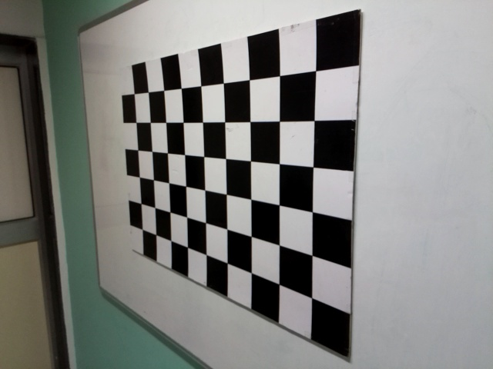

**OUTPUT**

**CALIBRATED IMAGE**

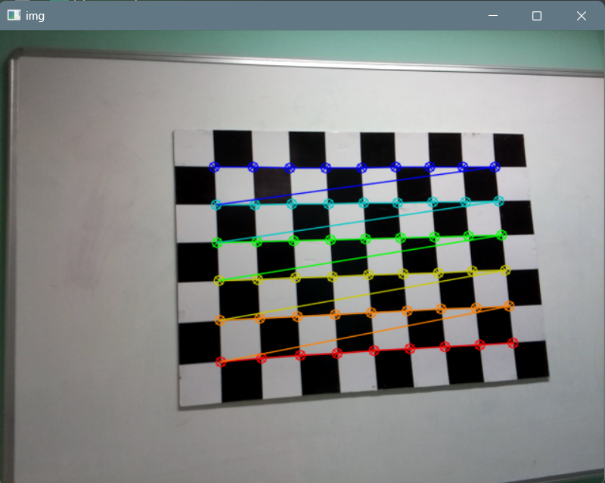

**POSE ESTIMATED IMAGE**

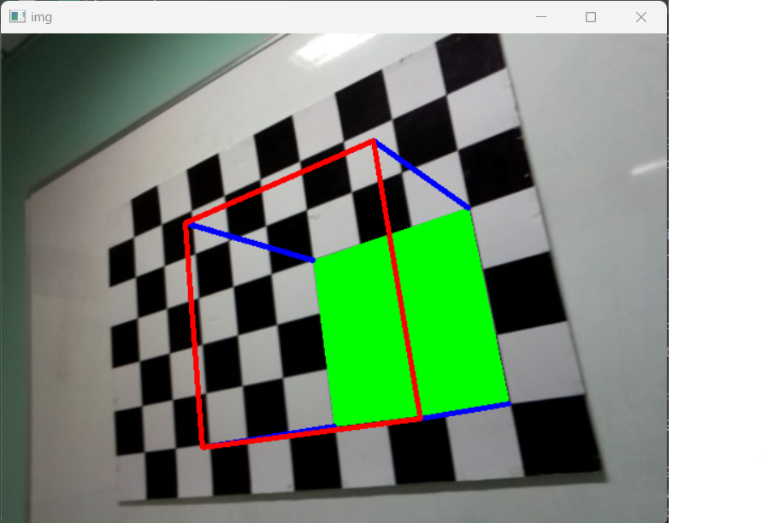

**FOR PNG IMAGE**

**INPUT**

import numpy as np  
import cv2 as cv  
import glob  
  
  
  
################ FIND CHESSBOARD CORNERS - OBJECT POINTS AND IMAGE POINTS #############################  
  
#chessboardSize = (24,17)  
#frameSize = (1440,1080)  
  
#chessboardSize = (10,17)  
frameSize = (640,480)  
  
# termination criteria  
#criteria = (cv.TERM_CRITERIA_EPS + cv.TERM_CRITERIA_MAX_ITER, 30, 0.001)  
  
  
# prepare object points, like (0,0,0), (1,0,0), (2,0,0) ....,(6,5,0)  
#objp = np.zeros((chessboardSize[0] * chessboardSize[1], 3), np.float32)  
#objp[:,:2] = np.mgrid[0:chessboardSize[0],0:chessboardSize[1]].T.reshape(-1,2)  
  
#size_of_chessboard_squares_mm = 20  
#objp = objp * size_of_chessboard_squares_mm  
  
# termination criteria  
criteria = (cv.TERM_CRITERIA_EPS + cv.TERM_CRITERIA_MAX_ITER, 30, 0.001)  
# prepare object points, like (0,0,0), (1,0,0), (2,0,0) ....,(6,5,0)  
objp = np.zeros((24*17,3), np.float32)  
objp[:,:2] = np.mgrid[0:24,0:17].T.reshape(-1,2)  
# Arrays to store object points and image points from all the images.  
objpoints = [] # 3d point in real world space  
imgpoints = [] # 2d points in image plane.  
  
images = glob.glob(r'C:\Users\21r231\PycharmProjects\pythonProject2\Calib\Im*')   
  
for image in images:  
  
 img = cv.imread(image)  
 gray = cv.cvtColor(img, cv.COLOR_BGR2GRAY)  
  
 # Find the chess board corners  
 #ret, corners = cv.findChessboardCorners(gray, chessboardSize, None)  
 ret, corners = cv.findChessboardCorners(gray, (24,17), None)  
 # If found, add object points, image points (after refining them)  
 if ret == True:  
  
 objpoints.append(objp)  
 corners2 = cv.cornerSubPix(gray, corners, (11,11), (-1,-1), criteria)  
 imgpoints.append(corners)  
  
 # Draw and display the corners  
 #v.drawChessboardCorners(img, chessboardSize, corners2, ret)  
 cv.drawChessboardCorners(img, (24,17), corners2, ret)  
 cv.imshow('img', img)  
 cv.waitKey(1000)  
  
  
cv.destroyAllWindows()  
  
  
  
  
############## CALIBRATION #######################################################  
  
ret, mtx, dist, rvecs, tvecs = cv.calibrateCamera(objpoints, imgpoints, frameSize, None, None)  
  
np.savez('B.npz', mtx=mtx, dist=dist, rvecs=rvecs, tvecs=tvecs)  
print('Calibration Completed')  
############## UNDISTORTION #####################################################  
  
img= cv.imread(r'C:\Users\21r231\PycharmProjects\pythonProject2\Calib\cali5.png')  
cv.imshow('img', img)  
h, w = img.shape[:2]  
newCameraMatrix, roi = cv.getOptimalNewCameraMatrix(mtx, dist, (w,h), 1, (w,h))  
  
# Undistort  
dst = cv.undistort(img, mtx, dist, None, newCameraMatrix)  
  
# crop the image  
x, y, w, h = roi  
dst = dst[y:y+h, x:x+w]  
cv.imwrite('caliResultss1.png', dst)  
  
  
  
# Undistort with Remapping  
mapx, mapy = cv.initUndistortRectifyMap(mtx, dist, None, newCameraMatrix, (w,h), 5)  
dst = cv.remap(img, mapx, mapy, cv.INTER_LINEAR)  
  
# crop the image  
x, y, w, h = roi  
dst = dst[y:y+h, x:x+w]  
cv.imwrite('caliResultss2.png', dst)  
  
  
  
  
# Reprojection Error  
mean_error = 0  
  
for i in range(len(objpoints)):  
 imgpoints2, _ = cv.projectPoints(objpoints[i], rvecs[i], tvecs[i], mtx, dist)  
 error = cv.norm(imgpoints[i], imgpoints2, cv.NORM_L2)/len(imgpoints2)  
 mean_error += error  
  
print( "total error: {}".format(mean_error/len(objpoints)) )  
  
np.savez('B.npz', mtx=mtx, dist=dist, rvecs=rvecs, tvecs=tvecs)  
  
###############################################################################################################  
  
# Load previously saved data  
with np.load('B.npz') as file:  
 mtx, dist, rvecs, tvecs = [file[i] for i in ('mtx','dist','rvecs','tvecs')]  
  
  
def draw(img, corners, imgpts):  
  
 corner = tuple(corners[0].ravel())  
 img = cv.line(img, corner, tuple(imgpts[0].ravel()), (255,0,0), 10)  
 img = cv.line(img, corner, tuple(imgpts[1].ravel()), (0,255,0), 10)  
 img = cv.line(img, corner, tuple(imgpts[2].ravel()), (0,0,255), 10)  
  
 return img  
  
  
def drawBoxes(img, corners, imgpts):  
  
 imgpts = np.int32(imgpts).reshape(-1,2)  
  
 # draw ground floor in green  
 img = cv.drawContours(img, [imgpts[:4]],-1,(0,255,0),-3)  
  
 # draw pillars in blue color  
 for i,j in zip(range(4),range(4,8)):  
 img = cv.line(img, tuple(imgpts[i]), tuple(imgpts[j]),(255),3)  
  
 # draw top layer in red color  
 img = cv.drawContours(img, [imgpts[4:]],-1,(0,0,255),3)  
  
 return img  
  
  
  
criteria = (cv.TERM_CRITERIA_EPS + cv.TERM_CRITERIA_MAX_ITER, 30, 0.001)  
  
#objp = np.zeros((24*17,3), np.float32)  
objp = np.zeros((24*17,3), np.float32)  
#objp[:,:2] = np.mgrid[0:24,0:17].T.reshape(-1,2)  
objp[:,:2] = np.mgrid[0:24,0:17].T.reshape(-1,2)  
axis = np.float32([[3,0,0], [0,3,0], [0,0,-3]]).reshape(-1,3)  
axisBoxes = np.float32([[0,0,0], [0,3,0], [3,3,0], [3,0,0],  
 [0,0,-3],[0,3,-3],[3,3,-3],[3,0,-3] ])  
  
  
for image in glob.glob(r'C:\Users\21r231\PycharmProjects\pythonProject2\CalibcaliResult*.png'):  
  
 img = cv.imread(image)  
 gray = cv.cvtColor(img,cv.COLOR_BGR2GRAY)  
 #ret, corners = cv.findChessboardCorners(gray, (24,17),None)  
 ret, corners = cv.findChessboardCorners(gray, (24,17), None)  
  
 if ret == True:  
 print('Pose Estimation Started')  
 corners2 = cv.cornerSubPix(gray,corners,(11,11),(-1,-1), criteria)  
 #print(corners2)  
  
 # Find the rotation and translation vectors.  
 ret, rvecs, tvecs = cv.solvePnP(objp, corners2, mtx, dist)  
  
 # Project 3D points to image plane  
 imgpts, jac = cv.projectPoints(axisBoxes, rvecs, tvecs, mtx, dist)  
  
 img = drawBoxes(img,corners2,imgpts)  
 cv.imshow('img',img)  
  
 # k = cv.waitKey(0)  
 # if k == ord('s'):  
 cv.imwrite('pose.png', img)  
cv.waitKey(0)  
  
  
#cv.destroyAllWindows()

**INPUT IMAGE**

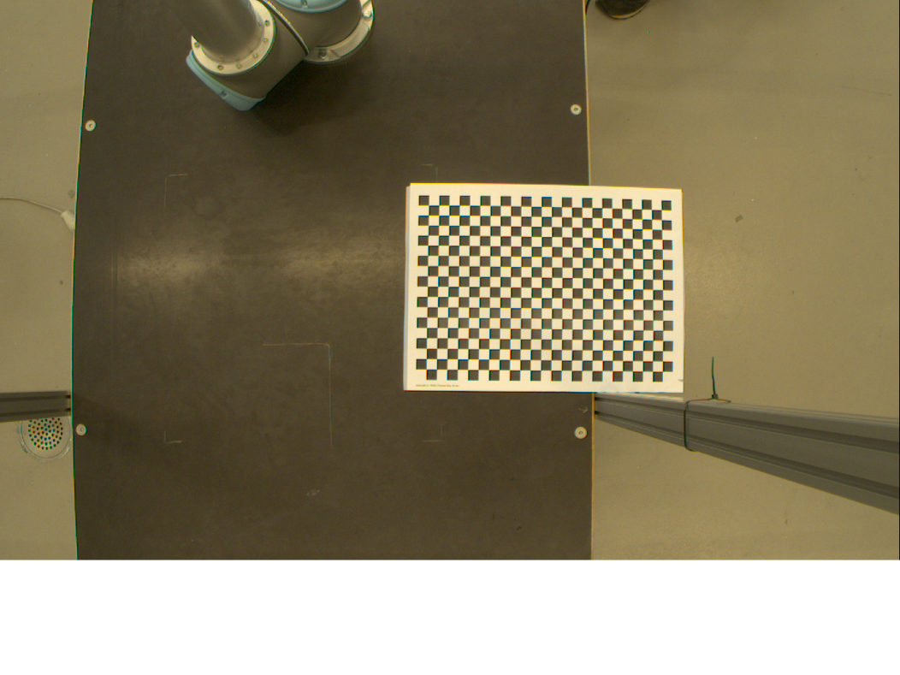

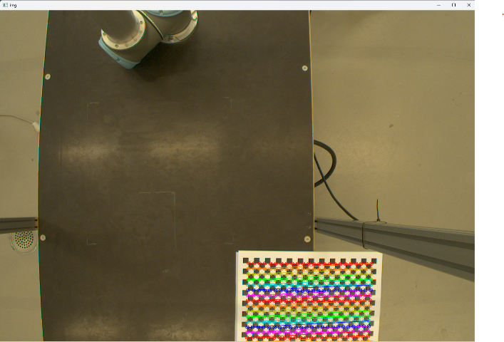**OUTPUT IMAGE**  
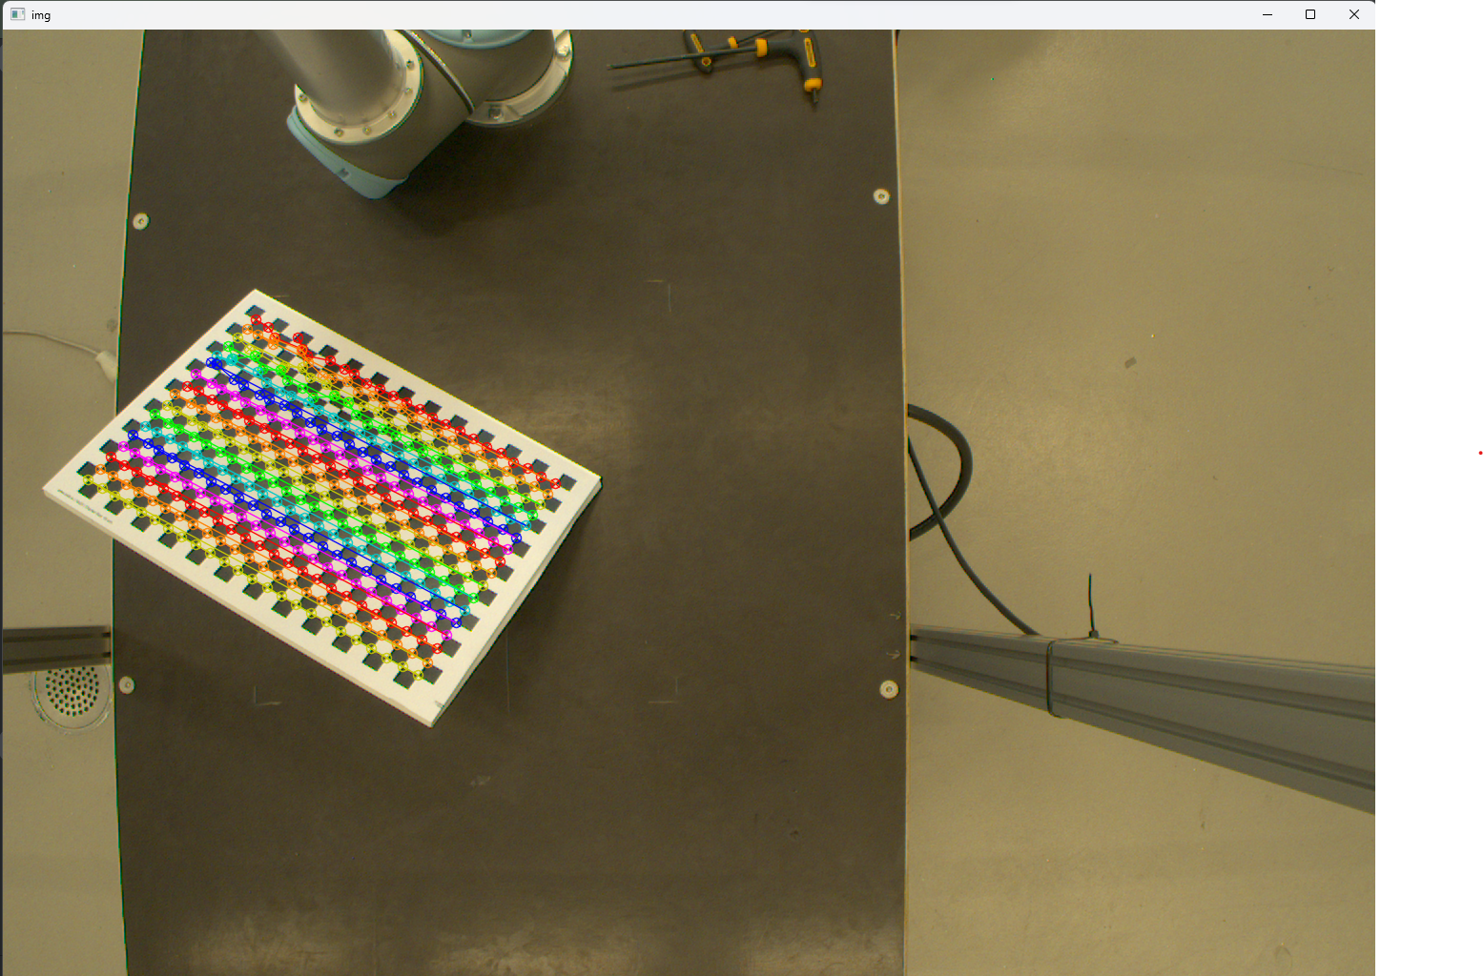

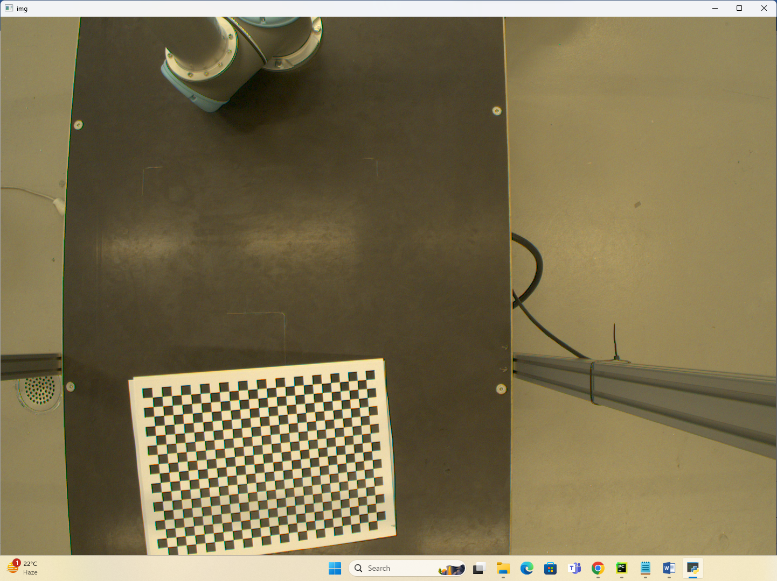

import numpy as np  
import cv2 as cv  
import glob  
  
frameSize = (816, 459)  
criteria = (cv.TERM_CRITERIA_EPS + cv.TERM_CRITERIA_MAX_ITER, 30, 0.001)  
  
# Prepare object points  
objp = np.zeros((24 * 17, 3), np.float32)  
objp[:, :2] = np.mgrid[0:24, 0:17].T.reshape(-1, 2)  
  
objpoints = [] # 3D points in real world space  
imgpoints = [] # 2D points in image plane  
  
images = glob.glob(r'C:\Users\rithi\PycharmProjects\pythonProject8\calib\Ima*.png')  
  
for image in images:  
 img = cv.imread(image)  
 gray = cv.cvtColor(img, cv.COLOR_BGR2GRAY)  
 ret, corners = cv.findChessboardCorners(gray, (24, 17), None)  
  
 if ret:  
 objpoints.append(objp)  
 corners2 = cv.cornerSubPix(gray, corners, (11, 11), (-1, -1), criteria)  
 imgpoints.append(corners)  
  
 cv.drawChessboardCorners(img, (24, 17), corners2, ret)  
 cv.imshow('img', img)  
 cv.waitKey(100)  
  
cv.destroyAllWindows()  
  
# Camera calibration  
ret, mtx, dist, rvecs, tvecs = cv.calibrateCamera(objpoints, imgpoints, frameSize, None, None)  
np.savez('B.npz', mtx=mtx, dist=dist, rvecs=rvecs, tvecs=tvecs)  
print('Calibration Completed')  
  
# Undistort image  
img = cv.imread(r'C:\Users\rithi\PycharmProjects\pythonProject8\calib\cali5.png')  
h, w = img.shape[:2]  
newCameraMatrix, roi = cv.getOptimalNewCameraMatrix(mtx, dist, (w, h), 1, (w, h))  
dst = cv.undistort(img, mtx, dist, None, newCameraMatrix)  
x, y, w, h = roi  
dst = dst[y:y + h, x:x + w]  
cv.imwrite('caliResult3.jpg', dst)  
  
# Reprojection Error  
mean_error = 0  
for i in range(len(objpoints)):  
 imgpoints2, _ = cv.projectPoints(objpoints[i], rvecs[i], tvecs[i], mtx, dist)  
 error = cv.norm(imgpoints[i], imgpoints2, cv.NORM_L2) / len(imgpoints2)  
 mean_error += error  
print("Total error: {}".format(mean_error / len(objpoints)))  
  
# Load calibration data  
with np.load('B.npz') as file:  
 mtx, dist, rvecs, tvecs = [file[i] for i in ('mtx', 'dist', 'rvecs', 'tvecs')]  
  
  
# Draw function for axis  
def draw(img, corners, imgpts):  
 corner = tuple(corners[0].ravel())  
 img = cv.line(img, corner, tuple(imgpts[0].ravel()), (255, 0, 0), 10)  
 img = cv.line(img, corner, tuple(imgpts[1].ravel()), (0, 255, 0), 10)  
 img = cv.line(img, corner, tuple(imgpts[2].ravel()), (0, 0, 255), 10)  
 return img  
  
  
# Draw function for boxes  
def drawBoxes(img, corners, imgpts):  
 imgpts = np.int32(imgpts).reshape(-1, 2)  
 img = cv.drawContours(img, [imgpts[:4]], -1, (0, 255, 0), -3)  
 for i, j in zip(range(4), range(4, 8)):  
 img = cv.line(img, tuple(imgpts[i]), tuple(imgpts[j]), (255), 3)  
 img = cv.drawContours(img, [imgpts[4:]], -1, (0, 0, 255), 3)  
 return img  
  
  
# Object points  
objp = np.zeros((24 * 17, 3), np.float32)  
objp[:, :2] = np.mgrid[0:24, 0:17].T.reshape(-1, 2)  
axis = np.float32([[3, 0, 0], [0, 3, 0], [0, 0, -3]]).reshape(-1, 3)  
axisBoxes = np.float32([[0, 0, 0], [0, 3, 0], [3, 3, 0], [3, 0, 0],  
 [0, 0, -3], [0, 3, -3], [3, 3, -3], [3, 0, -3]])  
  
# Pose estimation  
for image in glob.glob(r'C:\Users\rithi\PycharmProjects\pythonProject8\caliResult*.png'):  
 img = cv.imread(image)  
 gray = cv.cvtColor(img, cv.COLOR_BGR2GRAY)  
 ret, corners = cv.findChessboardCorners(gray, (24, 17), None)  
  
 if ret:  
 corners2 = cv.cornerSubPix(gray, corners, (11, 11), (-1, -1), criteria)  
 ret, rvecs, tvecs = cv.solvePnP(objp, corners2, mtx, dist)  
 imgpts, _ = cv.projectPoints(axisBoxes, rvecs, tvecs, mtx, dist)  
 img = drawBoxes(img, corners2, imgpts)  
 cv.imshow('img', img)  
 cv.imwrite('pose12.png', img)  
 cv.waitKey(0)  
  
cv.destroyAllWindows()

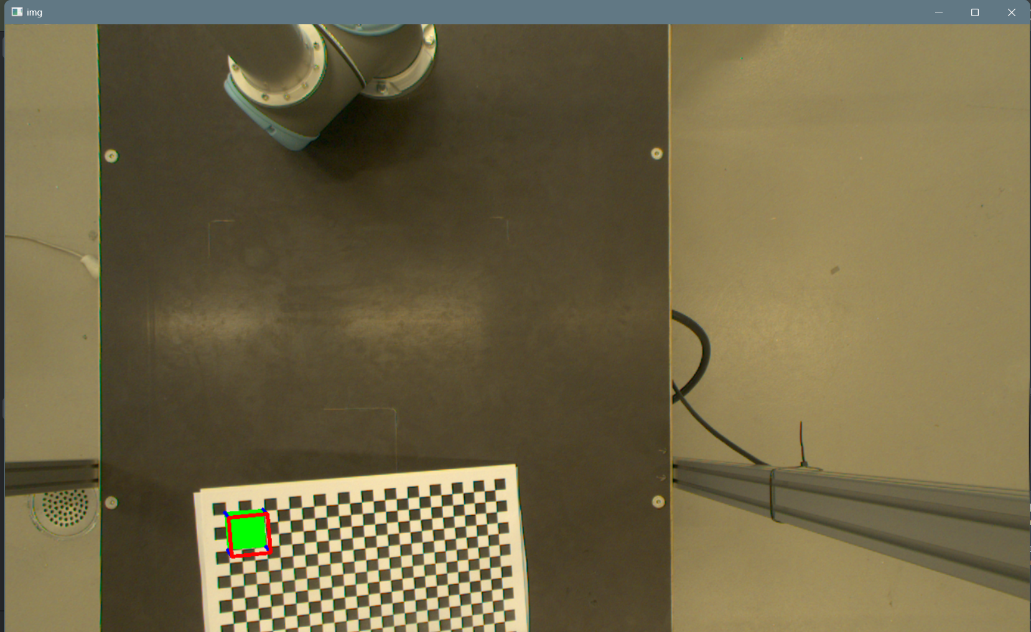

**Post Lab Questions**

1. **What are the challenges in camera calibration?**

**Lens Distortion**: Cameras often introduce distortion to images due to imperfections in the lens. Calibration helps correct for this distortion.

**Intrinsic Parameters**: Determining the intrinsic parameters of a camera (such as focal length, principal point, and skew) accurately is crucial for various computer vision tasks.

**Extrinsic Parameters:** Calibrating the extrinsic parameters involves determining the position and orientation of the camera relative to the scene.

1. **What is the function inbuilt function for camera calibration? Explain each argument.**

The OpenCV library provides an inbuilt function called cv2.calibrateCamera() for camera calibration.

objectPoints: Points in the real world coordinate space.

imagePoints: Points in the image plane.

imageSize: Size of the image.

cameraMatrix: Output camera matrix.

distCoeffs: Output vector of distortion coefficients.

rvecs: Output vector of rotation vectors.

tvecs: Output vector of translation vectors.

flags: Different calibration flags (e.g., cv2.CALIB_FIX_ASPECT_RATIO, cv2.CALIB_ZERO_TANGENT_DIST, etc.).

1. **What is the difference between disparity and depth? Explain how is disparity is related to pose estimation.**

**Disparity:** Disparity refers to the difference in horizontal coordinates of corresponding points in the left and right images of a stereo pair. It's used to infer depth information in stereo vision.

**Depth:** Depth refers to the distance of a point in the scene from the camera. It's typically measured in units like meters or centimeters and gives a direct understanding of the scene's 3D structure.

1. **What do you mean by the following code?**

criteria = (cv.TERM_CRITERIA_EPS + cv.TERM_CRITERIA_MAX_ITER, 30, 0.001)

cv.TERM_CRITERIA_EPS: Termination criteria based on the desired accuracy (epsilon).

cv.TERM_CRITERIA_MAX_ITER: Termination criteria based on the maximum number of iterations.

30: Maximum number of iterations allowed.

0.001: Desired accuracy (epsilon) for the algorithm to converge.

# 

# **Result:**

Thus, the calibration of a Monocular Camera and Pose Estimation ha been completed using OpenCV.